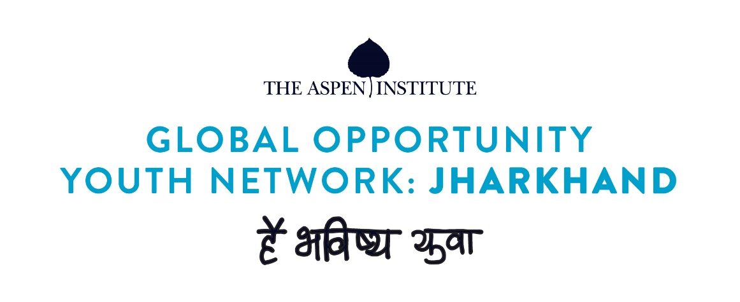

Background:
As global Opportunity Youth Network (GOYN) goes with the line: nothing for us without us! Youth are the central pillar to the initiative. The representation from youth is an integral part in co-designing. In order to achieve this, we have formed youth advisory group (YAG) in Ramgarh under GOYN. The identified youth in YAGs will have meetings on fortnightly basis wherein they can discuss about the problems and challenges and how they come up with innovative and appropriate solutions as per their context.
Objective of the workshop
The objective of the third YAG was to understand how YAG would want to collaborate. The session was around the following points:
- How can YAG members contribute to GOYN?
- What are the roles and responsibilities of YAG members?
- What are the activities around which YAG members will be engaged?
- Who are the potential stakeholders of the community and how can YAG engage with those stakeholders?
- How can we reach to the rural youth of Ramgarh?
The YAG meeting was facilitated by GOYN-Ramgarh team members
Process notes:
The third YAG meeting was held on 16th September,2020 at Ramgarh town. The duration of the meeting for 90 minutes. The meeting was divided into six phases:
- Recap from the last meeting and brief introduction about GOYN and its pillars
- Ice breaking exercise
- Group work and presentation
- Open discussion on the topic of engaging rural youth and creating a buzz within the youth community
- Questions/ comments/ feedback
- Conclusion and invitation to the next meeting
The meeting started with a brief recap about the last meeting and an introduction about GOYN global and India (Pune) context. The important pillars of GOYN were also mentioned along with the importance and role of YAG in GOYN context.
Introduction:
The youth were given an introduction about Global Opportunity Youth Network (GOYN) and were explained the concepts of GOYN, the co-designing aspect of the initiative and how the youth is an important pillar is the core of the project. The youth were also introduced towards the vision and mission of GOYN and how the initiative talks about bottom-up approach.
Ice breaking:
All the participants had to introduce themselves and name an animal which they like/ close to them. They also had to explain others about the reason why they like the particular animal. 3 minutes were given to the participants to think and then start with the introduction. The exercise made the participants to explore their personalities and share the good traits within them with everyone.
Group activity:
Group activity 1:
The YAG members have been coming together for two meetings and they have some level of understanding about GOYN, so in this session we decided to discuss about the role and responsibilities of YAG members. Rather than coming up with a set of roles for the YAG, the objective of this exercise was to make the YAG members think about the value they add in and what could be their role?
The participants were divided into 2 groups to discuss among themselves on the topic. The members were given 10 minutes for discussing in their groups and 5 minutes to present their points to the others. After the sharing of findings was over by both the teams, a consolidation was done by the participants nominated from both the team.
Below is the consolidation of the points shared by the YAG members:
- YAG will ensure to identify the problems/challenges/ concerns of the youth at village level and provide them with advisory support
- YAG will ensure youth participation in GOYN activities and play an action role in youth mobilisation
- YAG will ensure the voice of all segments of youth (minorities, SCs, STs, people with special needs, BPL, etc) be heard and inputs to be given in the designing of the initiative accordingly
- YAG will play an active role will act as youth champions in their communities and spread the message of GOYN
- Organise youth convening and enable cross learning for youth from different Blocks/Panchayats/ villages
Group activity 2:
After consolidation of the role of YAG members, as the second group activity, the participants mapped the immediate activities in which the YAG can be involved along with the potential stakeholders for implementing the activities. The participants were divided into two group and were given 20. After the 20 minutes discussion, 5 minutes was given for presenting as team and 10 minutes was given for consolidation.
Below is the consolidation from the findings of the exercise:
Sr.No | Immediate Activities | Potential stakeholder
 | Know the challenges of rural youth | YAG, youth committees (village level)
 | Provide guidance to the rural youth on life choices, emotional guidance | YAG, teachers, youth committees, skilling institutes
 | Provide guidance and support to youth interested in education | YAG, local academic institutions, CSOs
 | Awareness creation amongst youth about blind faith like witchcraft | YAG, village head, women groups, youth committees, Government officials
 | Awareness about Government schemes to the youth | YAG, village head, ward members, Govt officials
 | Awareness creation amongst rural youth on employment opportunities | YAG, youth committees, leverage women groups for information dissemination, skill training institutes

Open discussion:
An open discussion was facilitated to get an overview about the activities through which maximum youth can be reached as an entry level community activity for youth and create a buzz about GOYN in the villages. The YAG members suggested to organise/ club with ongoing activities
- Sports activity such as football match at village/ Panchayat level
- Competitions around cultural festivals. For e.g.: Karma & Sahrul are the major festivals in Ramgarh area. In these festivals there are village level folk dance competitions for the youth in which the entire village also participates.
- Collaborate with village head, school teachers and organise small events for youth around Durga puja and Chhat puja (upcoming festivities)
Conclusion
The major outcomes from the 90 minutes session was:
- The YAG have clarity about their roles & responsibilities
- The activities to be undertaken by YAG have been listed and the potential stakeholders are also listed
- Overview on the ways to engage youth at village/ panchayat level as entry point activities
Lastly, it was decided by the members to have the next YAG meeting on 30th September,2020 at 11:00 am at Ramgarh.
Participant list
Sr.No | Name | Block
 | Manish Kumar | Gola
 | Tukeshwar Mahto | Mandu
 | Yogeshwar Ram | Mandu
 | Sunny Karmali | Gola
 | Shankar Kumar | Mandu
 | Sanjeet Kumar Mahto | Mandu
 | Basant Kumar | Chitarpur
 | Anil Kumar Mahto | Mandu
 | Rohit Karmali | Gola
 | Vinod Kumar | Ramgarh
 | Loknath Kumar | Patratu
 | Rahul Gupta | Ramgarh

