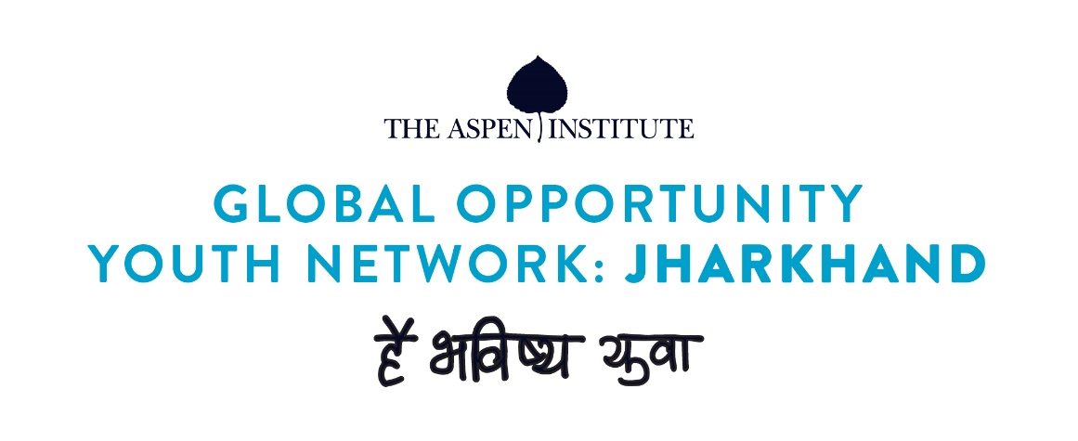

Background:
As global Opportunity Youth Network (GOYN) goes with the line: nothing for us without us! Youth are the central pillar to the initiative. The representation from youth is an integral part in co-designing. In order to achieve this, we have formed youth advisory group (YAG) in Ramgarh under GOYN. The identified youth in YAGs will have fortnightly meetings where in they can discuss about the problems and challenges and come up with innovative and appropriate solutions as per their context.
Participants in the first youth workshop:
On 29th June, 2020 the first orientation workshop for youth advisory group was organized. As this was the first youth orientation organized in Ramgarh about GOYN, opportunity youth from across the 6 six Blocks were reached out. The objective was to spread the message about GOYN. A total of 55 participants had participated for the half day session. These youth were majorly in the age group of 18-30 and represented diverse backgrounds.
Process note:
The half-day session was divided into six parts:
- Introduction about GOYN
- Introduction about YAG
- Knowing about the Ramgarh youth and their challenges
- What the youth is willing to contribute?
- Questions/ comments/ feedback
- Interactive session with Joel Miranda from YBI
Introduction to global opportunity youth network (GOYN) to Ramgarh youth:
Then the youth were introduced to global opportunity youth network (GOYN). The youth were explained the concepts of GOYN, the co-designing aspect of the initiative and how the youth is an important pillar is the core of the project. The youth were also introduced towards the vision and mission of GOYN and how the initiative talks about bottom-up approach.
A video on youth convening of Philadelphia was also shared by the youth to a perspective of how the youth play a leadership role in the community and talk about the challenges faced in their existing communities. This was a motivating video, as the youth came to know, most of the challenges faced by them are similar and they can be the agents of change in the community.
The youth were also introduced to the concept of youth advisory group (YAG) around to following topics:
- YAG as a youth representative body could add to youth leadership and as a platform for youth to talk about their challenges and their aspirations as well
- The YAG will also be a platform for ensuring the priorities, strategies and solutions identified by GOYN speak to the rural youth’s needs, concerns and aspirations.
- YAG representatives would also act as youth ambassadors in their respective localities and further help in connecting rural youth
In the next session, we had an interactive discussion about the challenges faced by the youth of Ramgarh and the constraints they think which should be addressed for improving the situation of youth in Ramgarh. Some of the challenges are listed down below:
- There are no options/ opportunities for youth in Ramgarh- there is lack of awareness about the existing opportunities as well as scope for new opportunities locally
- It is socially and physiologically difficult for the female candidates to migrate to big cities for placement, as they are not mostly unable to adapt to new conditions
- The youth does not get guidance on possible opportunities in education as well as employment. The counselling support is mostly missing
- Due to the present situation, most of the youth do not want to go back to cities and many lost their jobs.
- Majority of the youth present is interested to take up work around Ramgarh area but due to the present COVID situation, there are not many opportunities they could engage with
The youth also prepared a list of contributions to GOYN in Ramgarh:
- Life experiences
- Knowledge and information
- Capacity to work in communities
- Skills
Questions from the youth:
- How GOYN would involve youth as the center?
- How the youth would be benefitted by GOYN?
- What kind of role would the youth be involved in?
- What would be the role of youth advisory group?
- What are the benefits of youth involved in youth advisory group?
- what are the expectations of GOYN from youth involved in GOYN and youth advisory group?

Interactive session with Youth Build International by Joel Miranda:
An interactive session was organized by Mr. Joel Miranda from Youth Build International, global design partner interacted with the youth. Some of points discussed are as follows:
- Role of young people within GOYN
- Joel presented the global need for youth voice and vision
- Opportunity that exists before them to join local GOYN efforts, local network members and the importance of becoming a YAG representative
The session closed with Q&A moment where the young people asked Joel for his thoughts and advice. Below are the questions asked by the youth:
- How they could motivate and engage other young people in the community
- How they could engage adults in the community
- How the youth can make their voice heard and have lasting impact on the community
Conclusion:
The day was concluded by asking the youth to share the key messages and learnings from the half day session. Youth were also briefed about the working model of youth advisory group, about the frequency of meetings which would be organized every month and they were invited for the next meeting. The day was wrapped up with a group photograph.
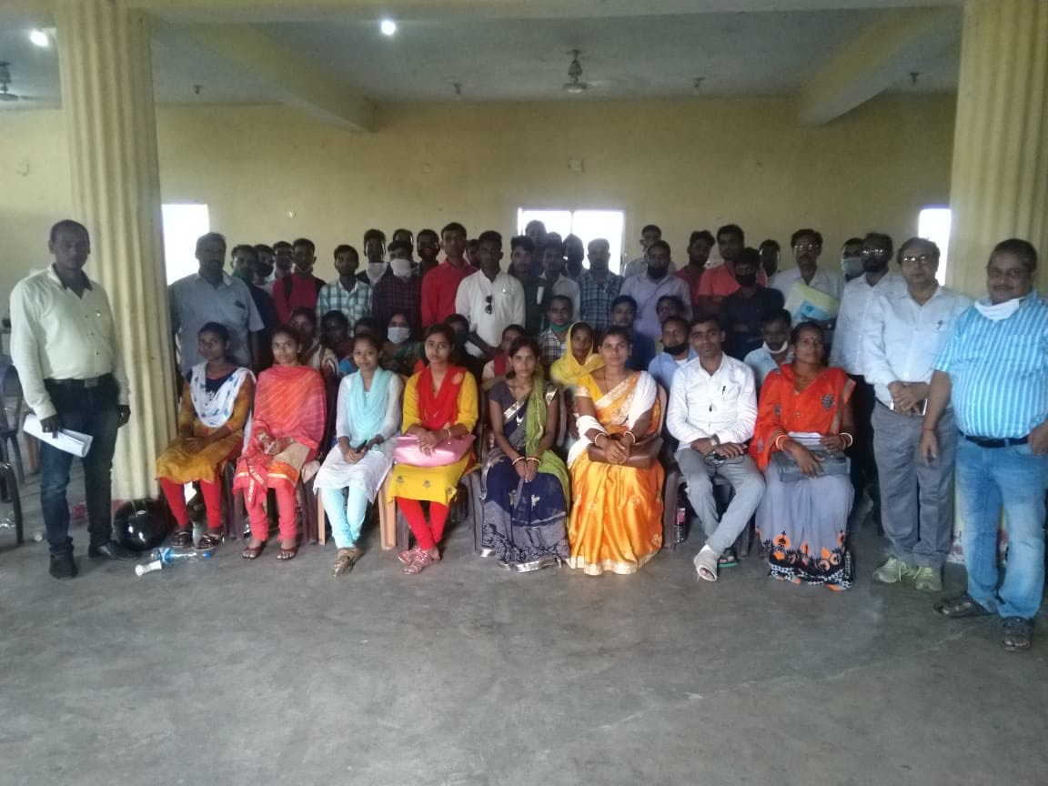

Participant list:
Sr.No | Name of participant
 | Anup kumar Sinha
 | Nikhil Kumar Sinha
 | Aaditya Kumar
 | Manoranjan Mahto
 | Md. Nehal Ansari
 | Sunil Kumar Munda
 | Renu Kumari
 | Sajda Noori
 | Pancham Kumar
 | Parmeshwar Mahto
 | Geeta Devi
 | Loknath Kumar Mahto
 | Ramesh Kumar
 | Md.Kasif Iqbal
 | Pranab Kumar
 | Kunti Kumari
 | Kalawati Kumari
 | Anawari Khatoon
 | Pankaj Kumar
 | Nomi Devi
 | Malti Devi
 | Meena Devi
 | Khushboo Kumari
 | Kumari Usha
 | Bhirni Devi
 | Ranjan Kumar Sahu
 | Rabindra Kumar
 | Ranjan Kumar
 | Mohit Kumar Mahto
 | Omesh Kumar
 | Ramesh Kumar
 | Rajesh kumar Mahto
 | Prakash Karmali
 | Md. Bilal Ansari
 | Binita Verma
 | Pallavi Kumari
 | Sunita Kumari
 | Mithilesh Kumar
 | Rajendra Murmu
 | Istiyak Alam
 | Chandan Kumar
 | Anil Kumar Mahto
 | Deepak Kumar
 | Rahul Kumar
 | Jaydev Bediya
 | Shiv Kumar Bediya
 | Prambir Singh
 | Suraj Kimar Munder
 | Mukesh Oraon
 | Pawan Kumar Munda
 | Dheeraj Munda
 | Shashi Kumar
 | Rajendra Kumar
 | Shyam Sundar
 | Kuldeep Kumar

