FIFTH YOUTH WORKSHOP
ACTION PLANNING

12 November 2019

GLOBAL OPPORTUNITY YOUTH INITIATIVE

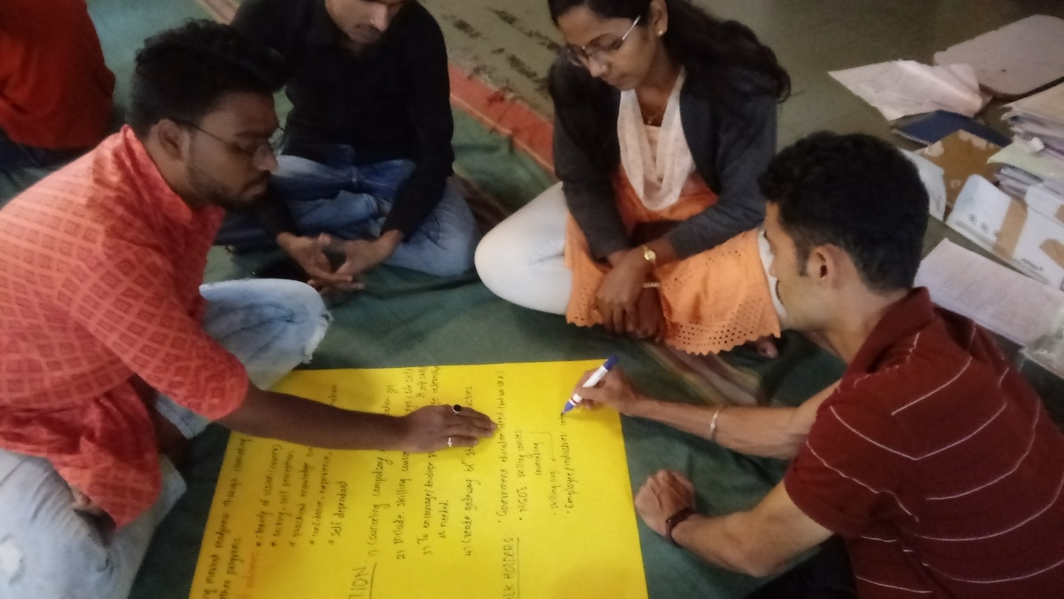

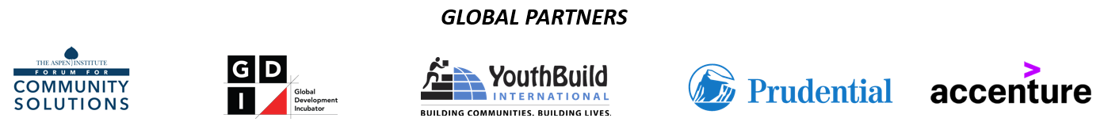
Objective
This workshop was the fifth and final in a series of five workshops with the following objectives:
- Re-convene the youth working group that would create an outline for the presentation to be delivered at the 14 November Partners Gathering
- Review the 7 Opportunity Pathways identified for GOYI Pune
- Create actions plans with desired outcomes, actions to be taken, and stakeholders to engage around each of the Opportunity Pathways
The workshop was co-facilitated by Joel Miranda of YouthBuild International, a member of the GOYI Global Partner Team and Bobby Zachariah of GOYI Pune. Twelve young people were in attendance, representing the different neighborhoods and organizations that participated in the previous four workshops.
Attendees:
S.No. | Name of participant. | Organization
1 | Poonam Chavan | Yerawada lighthouse
2 | Kokare Vishal | Aundh Lighthouse
3 | Prajakta Rokade | Hadapsar Lighthouse
4 | Vidya | Aundh Lighthouse
5 | Pritesh Kamble | CYDA, Pune
6 | Preskumar | ???
7 | Amit Kumar Singh | Pratham Infotech Foundation
8 | Shubham Bhagwat | Tata Strive
9 | Shankar Kari | Tata Strive
10 | Samir | Aundh Lighthouse
11 | Mayuri Dalavi | NewVision
12 | Mangal Kale  15 years | NewVision

Process
- The young people were invited to review the list of 6 priority stakeholders they identified during the previous workshop.

- As a group, the young people then reviewed and discussed the 7 Opportunity Pathways identified for GOYI Pune. They sought clarification, as needed.

- Next, the young people were divided 3 small groups and each group was asked to select 1 of the 7 Opportunity Pathways and identify the following:
  - Desired outcomes for the selected Opportunity Pathway
  - Actions that should be taken by stakeholders and by young people in order to achieve the desired outcomes
  - Stakeholders that should be engaged in the actions towards the desired outcomes
The above outlined process continued until outcomes, actions, and stakeholders were identified for each of the 7 Opportunity Pathways

- The young people shared their flip charts with each other and discussed any questions or suggestions their peers had, making edits accordingly.

- Next, the group discussed and proposed the flow for the presentation to be delivered at the 14 November Partners Gathering. A final version of the proposed presentation has been provided below this report.

Next steps:
- All young people who are available, will meet on 13 November at Aundh Lighthouse to practice for the presentation scheduled for 14 November.
- All young people who volunteered to present, agreed to arrive at the meeting venue by 8 AM on 14 November in order to do a “dry run” of the presentation in the meeting hall.

