FOURTH YOUTH WORKSHOP
STAKEHOLDER PRIORITIZATION

9 November 2019

GLOBAL OPPORTUNITY YOUTH INITIATIVE

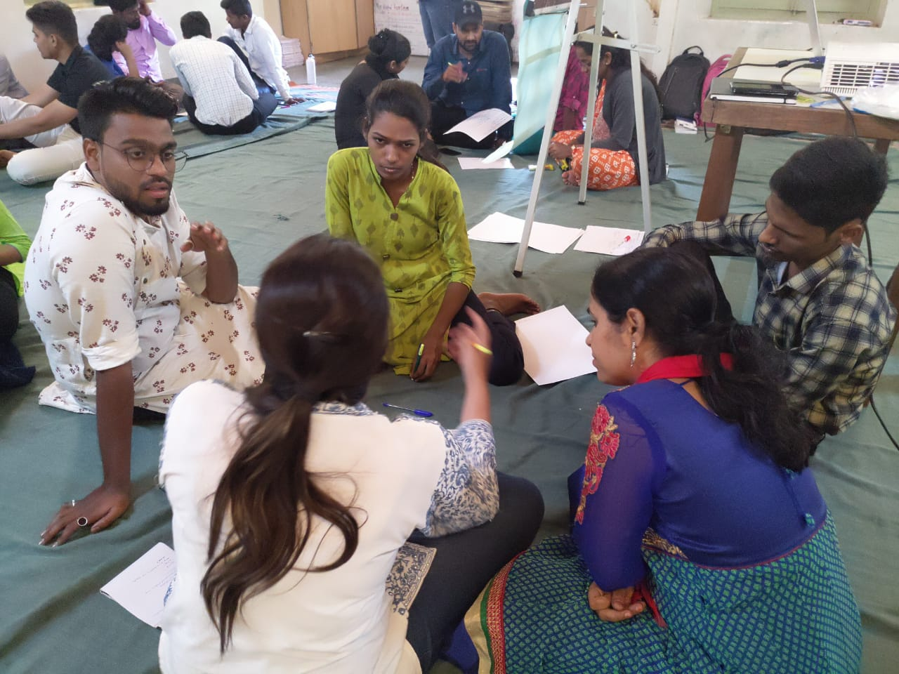


Objective
This workshop was the fourth in a series of five workshops with the following objectives:
- Convene and establish a working group that would create and present at the 14 November Partners Gathering
- Review the challenges and potential solutions generated by young people across Pune during the 3 previous youth workshops
- Review the 7 Opportunity Pathways identified for GOYI Pune
- Identify stakeholders that should be engaged in creating solutions that align with the 7 Opportunity Pathways
The workshop was co-facilitated by Joel Miranda of YouthBuild International, a member of the GOYI Global Partner Team and Bobby Zachariah of GOYI Pune.

Process
- The young people were invited to look around the room at the flipcharts from the 3 previous youth workshops. They were asked to review the challenges and solutions that were generated by young people from different neighborhoods and organizations in Pune. They were asked to think about what it would take to create those solutions and who should be part of that solution creation process?
- As this group of young people represent different parts of the city, different organizations, and were convened over 3 different workshops, they were invited to participate in a team building activity like the building activity facilitated during the third workshop. They were encouraged to think about all the different actors that will need to be engaged to create solutions and how they might work together across such a big city like Pune.
- Next, the young people were re-introduced to the 7 Opportunity Pathways for GOYI Pune:
  - Enabling 'agency', life-skills and attitude shifts for youth
  - Ensuring market-readiness through counselling, skilling and apprenticeships and other programs
  - Strong industry partnership for effective job-skill matching
  - Post-placement support to youth as well as organizations
  - Building a supportive entrepreneurship ecosystem
  - Enabling support structures for women to be entrepreneurs/gain employment
  - Building linkages between various stakeholders including youth, Government, skilling partners, industry and NGOs for leveraging existing programs and ensuring last-mile connectivity
- After reviewing the challenges and solutions generated by young people across Pune, and the 7 Opportunity Pathways, the young people were asked to generate a list of all the people, groups and organizations that should be engaged in GOYI efforts to create the solutions identified by young people. The solutions also needed to be in alignment with the 7 Opportunity Pathways. The young people generated a list of over 40 people, groups, or types of organizations.
- The young people were then invited to review their larger list and discuss how they might distill, combine, and group the list of all the people, groups and organizations that should be engaged in GOYI efforts.
- Through small group conversations, and a larger group discussion during which a few youth took a leadership role and helped combine the list, the group distilled the larger list into 6 stakeholder groups that represent all of the people or groups that they identified. The images below show the actual brainstormed list and the combined list of stakeholder groups.
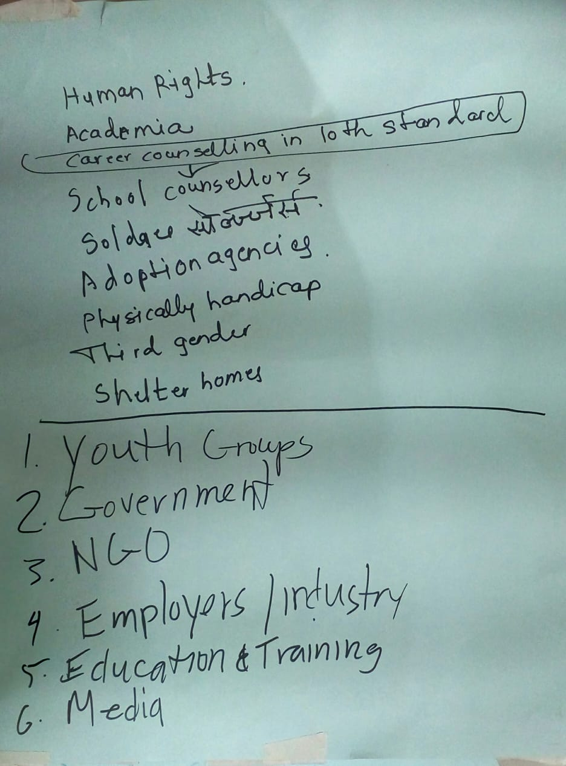
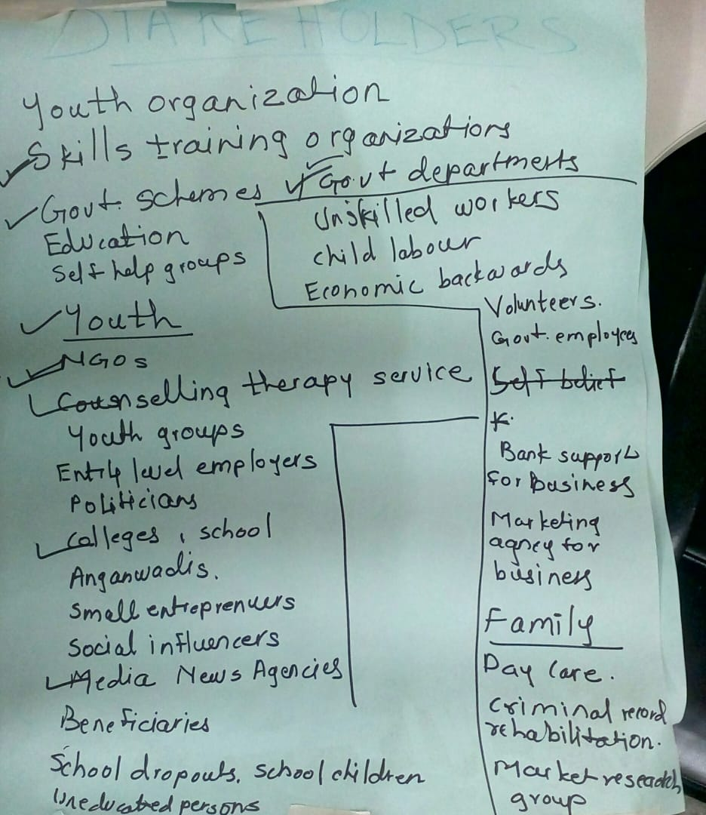
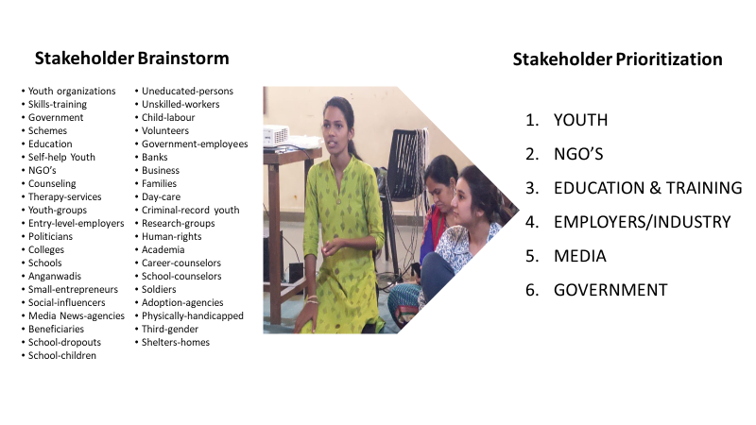

Next steps
This working group of young people agreed to meet for a fifth working group session to create a set of desired outcomes and actions aligned with the 7 Opportunity Pathways and identify which stakeholders should be engaged for each pathway.

PARTICIPANT LIST

S.No. | Name of participant. | Organization
1 | Poonam Chavan | Yerawada lighthouse
2 | Kokare Vishal | Aundh Lighthouse
3 | Prajakta Rokade | Hadapsar Lighthouse
4 | Ayodhya Gondhali | Aundh Lighthouse
5 | Pritesh Kamble | CYDA, Pune
6 | Surekha Unecha | Lighthouse
7 | Amit Kumar Singh | Pratham Infotech Foundation
8 | Chandraprakash Nagnath Suryatal | NSS, Bharati Vidyapeeth
9 | Soham Jagtap | Tata Strive
10 | Shubham Bhagwat | Tata Strive
11 | Shankar Kari | Tata Strive
12 | Bhavna Rajesh  Mavchi | NSS, Bharati Vidyapeeth
13 | Mayuri Dalavi | NewVision
14 | Mangal Kale  15 years | NewVision
15 | Jayshree Sachin Kamble | Yardi
16 | Sachin Kamble | Yardi
17 | Hariom Gupta | Pratham Infotech Foundation
18 | Ruksar Shaikh | Hadapsar Lighthouse
19 | Aashiya Shaikh | Lighthouse

