THIRD YOUTH WORKSHOP
AUNDH LIGHTHOUSE

8 November 2019

GLOBAL OPPORTUNITY YOUTH INITIATIVE
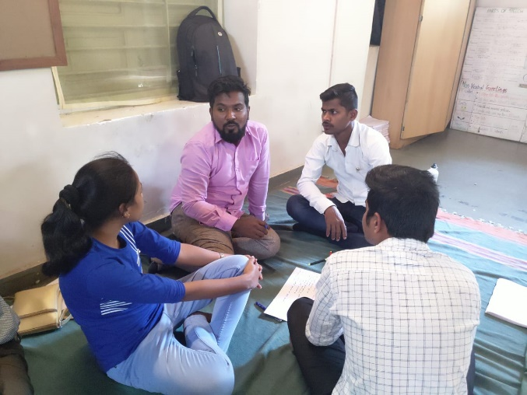
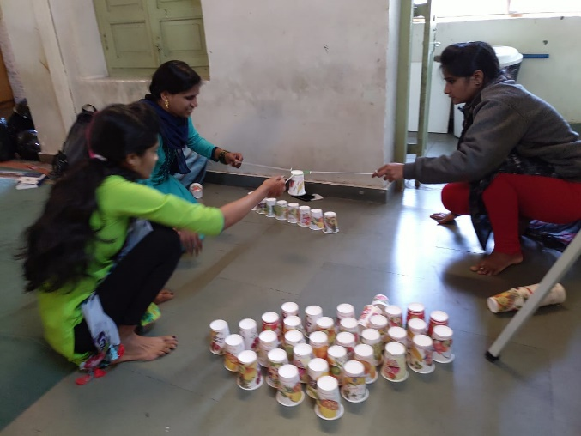

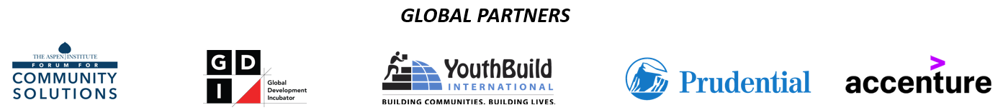
Objective
This workshop was the third in a series of five workshops with the following objectives:
- Connect with Opportunity Youth (OY) from the 6 Pune City Connect Lighthouses.
- Introduce Lighthouse participants to the goals of GOYI
- Build community between young people from different parts of the city
- Identify young people to be invited to join subsequent action planning sessions/meetings
The workshop was facilitated by Joel Miranda of YouthBuild International, a member of the GOYI Global Partner Team.
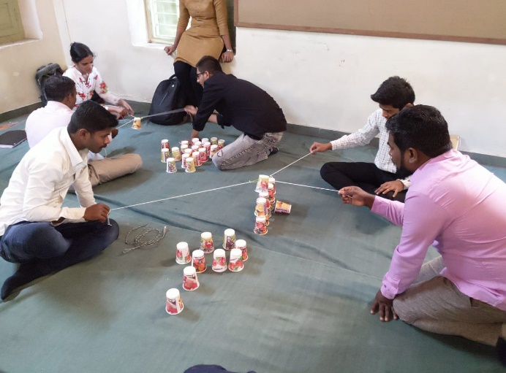
Process:
1. After a round of introductions, the group of 54 youth were divided into small groups of 6 youth. Each group of 6 was asked to create a structure using only plastic cups, strings, and rubber bands. They were directed not to touch the cups and to make sure that all members of the team were involved in building the structures.
The young people were instructed to think about the cups as opportunity youth in the community, and the strings and rubber bands as the supports and opportunities that young people would need in order to access quality livelihoods. Each group was instructed to strategize and devise a plan for how they would use the tools provided to support the young people (the cups) and build structures that could stand independently.
After 20 minutes, the groups were brought together to debrief the activity and share their experience. Some groups were able to build tall independent standing structures. Others were able to build foundations for structures, and yet others were able to devise a plan but were not yet able to move on to building the actual structures.
During the debrief, the young people shared that it was important to understand how close and how tightly the strings and rubber bands should be held to the cups and how much tension from the string or support from the rubber band each cup needed. Holding the string and rubber band too close and too tight could crush the cup or cause it to shake too much. Holding the string too far away and rubber band too loosely, would cause the cup to swing making placement of the cup almost impossible.
They saw this as a metaphor for thinking strategically about what types of supports young people in the community need and when those supports most needed. They also realized that in order to adequately build their structures, every person in the group needed to participate, and stay connected to the cup via the strings or the rubber bands, so that they were providing the right amount of support in order to lift the cup and safely place it so that the structure could stand on its own.
2. Next, the young people were introduced to the “Building My Hive” challenge and solutions- based activity. The activity uses the metaphor of young people as bees and their communities as hives:
- The hive structure (hexagon – 6 sided) is considered one of the strongest shapes and structures in nature. The communities that young people come from are strong and resilient and are like the hive.
- Scientists predict that without bees, humanity cannot last more than 4 years as a species. However, bees are feared and endangered similar to how opportunity youth are sometimes feared or misunderstood and endangered by poverty and a shortage of livelihood opportunities.
- Young people are like the bees. They are the builders of community.
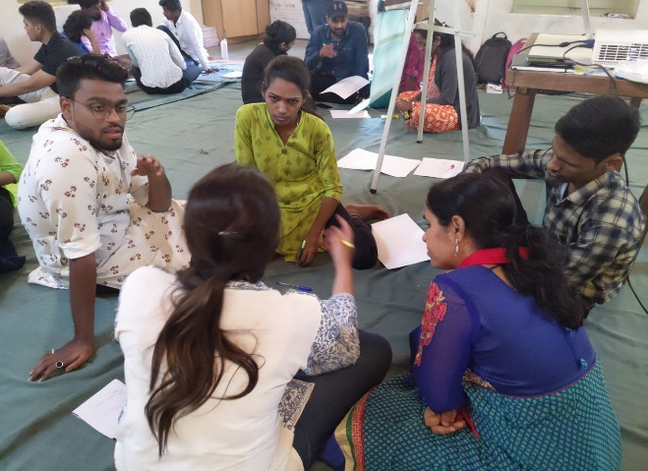
In groups of 6, the young people were instructed to identify individual community challenges that acted as barriers to quality livelihoods.
The groups then identified the most prominent common problem that connects to all the challenges they listed. The groups then shared those challenges with each other.
Each small group then reconvened and discussed potential community-specific solutions to the common problems or challanges. They were asked to document all the potential solutions they generated.
The following is a combined list of the challenges the young people identified and the lists of potential solutions they generated.

EDUCATION, TRAINING, AND SKILLING
Challenges | Potential solutions
Lack of knowledge/awareness of, and access to, quality education and training opportunities  Lack of skills leading to depressed mindsets  Language barriers (limited English communication proficiency)  Lack of awareness of government schemes | Provide scholarships to financially challenged youth  Start “learn and earn” programs for students with financial needs  Increase efficiency of education system; students skilling courses linked to quality careers should be mandatory  Provide financial skills awareness courses to all youth  Create platform to educate youth about government schemes  Provide free English language communication courses to all youth  Increase opportunities for women to access and attend education and training programs

PLACEMENT SUPPORTS
Challenges | Potential Solutions
Young people are not supported once they are placed  Employers do not understand the challenges youth face | Placement organizations conduct ongoing visits and supportive services for 3-6 months after placement  Employers should be educated on how to engage Opportunity Youth

COMMUNITY AND PERSONAL SAFETY
Challenges | Potential solutions
Women do not feel safe and need access to better education, training, and career opportunities  Rape and sexual harassment | Make people aware about sexual harassment  End workplace harassment of women  Provide safety courses for women  Offer women empowerment education
FAMILY SUPPORTS
Challenges | Potential Solutions
Families with children need support for childcare  Families often require that mothers stay home to care for children | Provide daycare centers so that mothers who want to work can access skilling and placement programs and can access meaningful livelihood opportunities  Families need to be educated about the importance of women entering skilling courses and establishing careers

Conclusion & Next Steps
The Opportunity Youth of Pune have a clear understanding of the challenges that they face when trying to access meaningful livelihoods. They are intimately connected to these challenges because of their socio-economic realities. Their lived experiences have built in them extreme resilience and the understanding and intelligence that makes them experts on their realities. Consequently, they are keenly aware of the solutions that are needed in order to create meaningful livelihood opportunities for themselves and their peers.
Upon concluding this 3rd workshop, the Lighthouse participants were informed of next steps related to convening a working group that would identify stakeholders and next steps around the 7 Opportunity Pathways identified for GOYI Pune.
Four youth were then invited to attend stakeholder prioritization and action planning workshops that would take place on 9 and 12 of November.

