SECOND YOUTH WORKSHOP

6 November, 2019

GLOBAL OPPORTUNITY YOUTH INITIATIVE
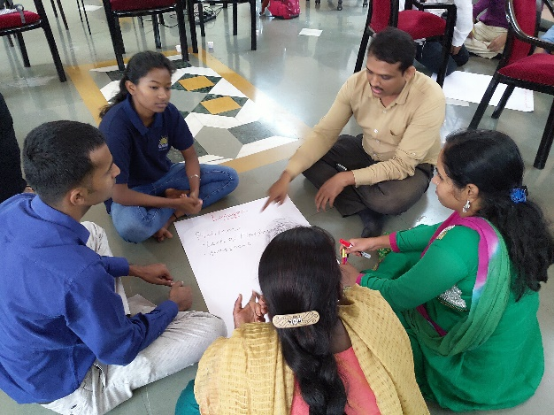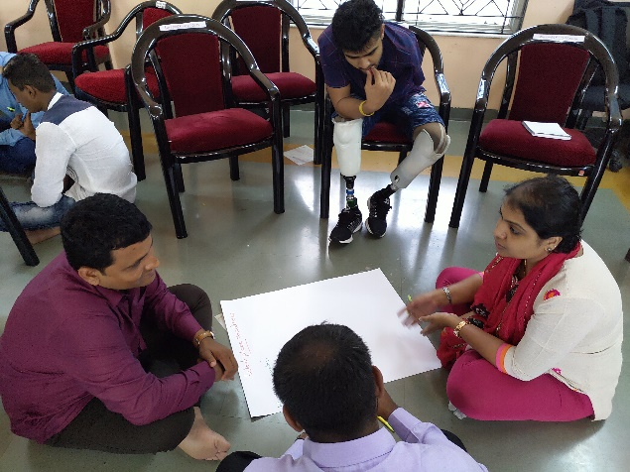

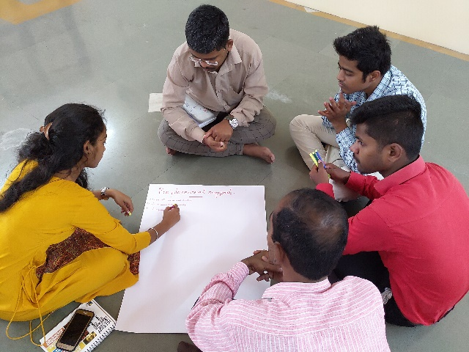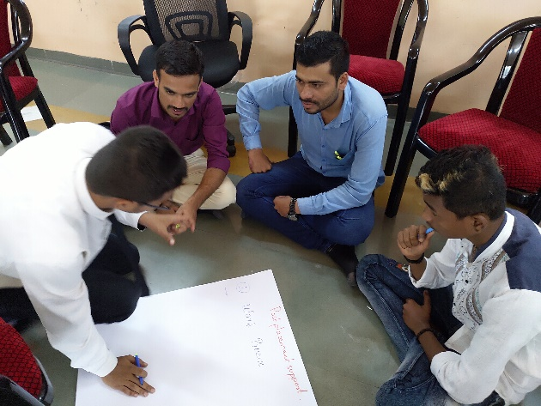

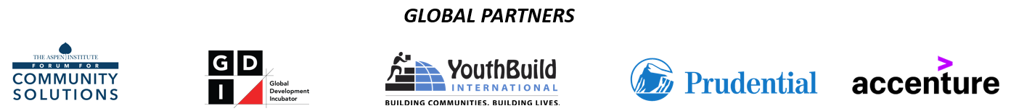
Objective
This workshop was the second in a series of five workshops with the following objectives:
- Connect with Opportunity Youth (OY) across the city of Pune.
- Listen to the challenges and dreams of the OY
- Share the vision for Global Opportunity Youth Initiative and identify young people who would like to participate in the execution of the vision
The workshop was facilitated by the GOYI team of Chandni Parekh and Bobby Zachariah
Process:
This was a four-hour workshop that started with participants getting to know each other over lunch. Subsequently, the following questions were explored together:
- What is GOYI?
- What are our concerns and hopes regarding employment?
- What are our action plans to address our concerns?
The reflections from the participants are captured in the following tables.
LINKAGES OF YOUTH WITH EMPLOYMENT ECO SYSTEM
Our Concerns | What is our way forward?
We lack a platform  We are unaware  We lack knowledge and education  Lack of communication skills  There is a lot of negative political influence  We as youth have unrealistic aspirations  The need for references to get a job is a challenge  There is a lack of knowledge regarding the resources that are available for us  There is a mismatch of expectations  Our lack of soft skills is a major barrier  We lack motivation  Lack of courses that can help us adapt to the job market  We cultivate a wrong attitude from a young age  There is a lack of dignity for some jobs  The youth who have migrated from villages to cities do not have access to education.  We do not have the necessary identity and address documents and hence cannot access many opportunities  We have an education degree, but no employable skills  We have been brought up in a pampered environment by our parents and hence we lack the right attitude.  We are lured by fast money and temporary jobs  We lack a vision for career | A skill gap analysis  A platform should be created  Provide opportunities for interaction

POST PLACEMENT SUPPORT
Our Concerns | What is our way forward?
We feel work pressure  English language is a difficulty for us  We desire to have a job with high salary | We try to declutter our mind on our own  We try to manage things on our own  We discuss our problems with our seniors

AGENCY AMONG YOUNG PEOPLE
Our Concerns | What is our way forward?
High expectations  Family members expect that their children should earn high wages, but not work too hard  Parents pamper their children a lot  Since no jobs are available, youth prepare for Maharashtra Public Service Commission exam to secure a government job  Mediators and job agents are not helpful. We should be able to approach employers directly  Many youths are motivated with wrong things.  Our dreams are not clear. Goals are not set  For some, education was forced upon us, though our dreams and aspirations were different  We are unable to express our thoughts  Lack motivation since we are doing work that we do not like | Hard work is a must  Accepting our mistakes and working on it  Practical implementation of knowledge is important  Our environment plays a vital role.  Influence youngsters  Start at a much younger age, when their life journey begins

PRE PLACEMENT SUPPORT
Our Concerns | What is our way forward?
Lack of technical skills  Lack of communication skills  We lack English language skills  We lack support and guidance  We lack identity and address documents | Flexible course duration  Proper planning  Economical support  Timing  Job guidance  Appropriate salary

WORK PLACE READINESS
Our Concerns | What is our way forward?
Mental preparation  Mismatch of interest / skill and the work that was given to us  Physical weakness / health issues  Emotional instability  Lack the appropriate skills for the sector  We lack confidence  Lack of communication  Readiness to travel and work hard  Ego problems  Work / job is only done for money and not for personal growth  Language barriers  Peer influence | Inherent values  Aware of the work done and growth opportunities available  Ready to learn new skills and not forced upon us  Build confidence  Build good communication skills – regional language, English, good way of expression  Related to goal. Step forward to take the goal  Flexible – for learning, time and new knowledge (technology)  Multi-tasking  Technical training / knowledge  Cultivate interest and aptitude  Learn interview related skills  Build up to date knowledge

Conclusion & Next Steps
The participants from organisations across Pune shared their concerns and connected with each other.
Youth expressed their desire to take charge, by articulating their next steps and to be a part of the larger of decision making. The youth were informed about the Youth Advisory Group and their opportunity to contribute to the emerging pathways.
Three youth from the group were invited for the 14 November, Partner’s gathering, to present the youth action plans.
PARTICIPANT LIST
S.No. | Name of participant. | Organisation
1 | Tinkesh Kaushik | Ekansh NGO
2 | Shreya Zhade | Aakanksha Foundation
3 | Pramodini Kharat | Aakanksha Foundation
4 | Rama Nagtilak | Aakanksha Foundation
5 | Sharan Khandu | Magic Bus Foundation
6 | Avinash Rawlu | Magic Bus Foundation
7 | Mr. Dnyaneshwar Ghuge | Mitcon
8 | Supriya | Mitcon
9 | Sagar Chatterjee | Tata Strive
10 | Vivek Pawar | Tata Strive
11 | Soham Jagtap | Tata Strive
12 | Shubham Bhagwat | Tata Strive
13 | Shankar Kari | Tata Strive
14 | Swati Kamble | Yardi Foundation
15 | Chaitrali | Yardi Foundation
16 | Umesh Bagal | Yardi Foundation
17 | Uma Dhotre | KMKGV
18 | Mrudulla | KMKGV
19 | Hariom Gupta | Pratham Infotech Foundation
20 | Amit Kumar Singh | Pratham Infotech Foundation
21 | Sunil Pote | KTI
22 | Yogesh | KTI
23 | Aashiya Shaikh | Lighthouse
24 | Did not register their names | Bharosa Cell
25 | Did not register their names | Bharosa Cell

